Community College of Baltimore County Labor Studies Program
Workplace Rights Project
Group or Concerted Activities at Work
http://youtu.be/Q8KIKjpwwA8
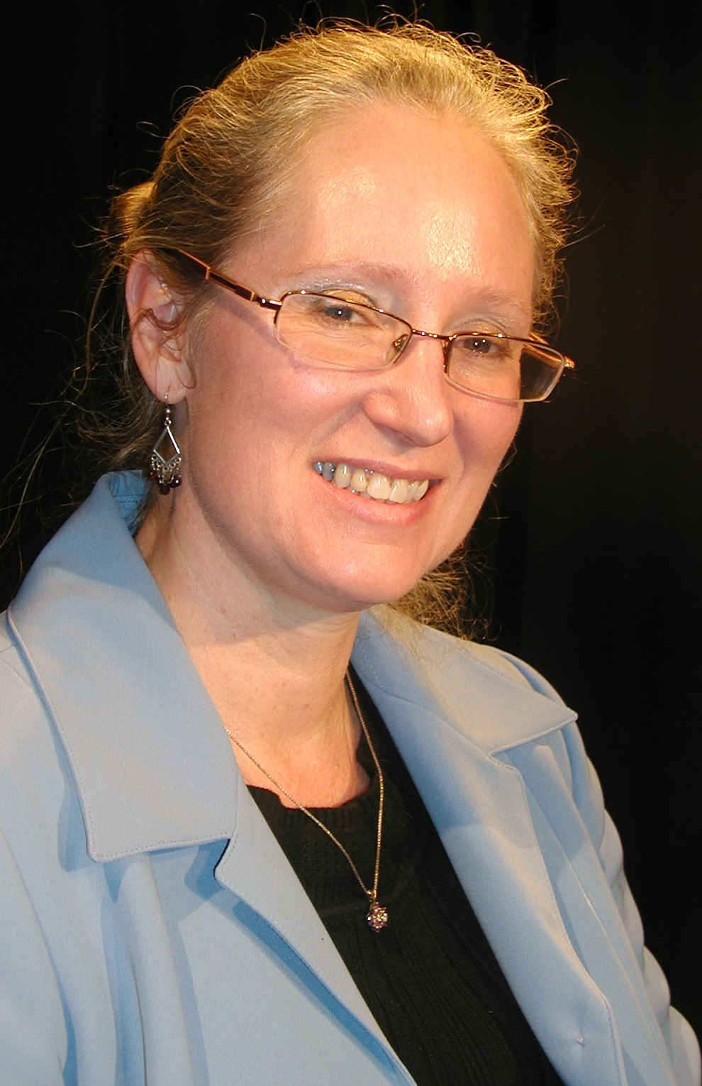
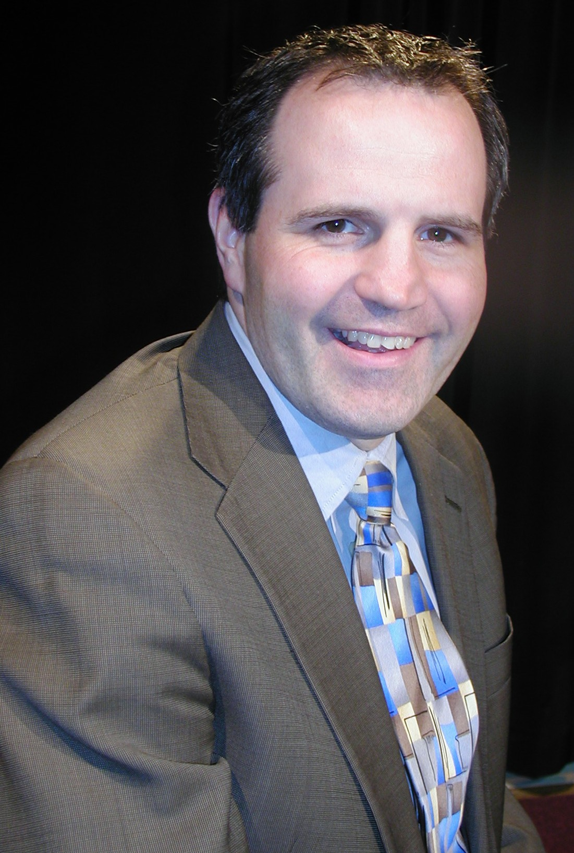

Linda S. Harris Crovella John D. Doyle, Jr.
Supervisory Field Attorney Deputy Regional Attorney
The National Labor Relations Board, Region 5
103 South Gay Street, 8th Floor
Baltimore, MD 21202
TEL: (410) 962-2822 FAX: (410) 962-2198
Employee Rights
https://www.nlrb.gov/rights-we-protect/employee-rights
New NLRB Elections Rules
https://www.nlrb.gov/node/3608
What is “Concerted Activity?”
http://www.lawmemo.com/articles/non-union.htm
The NLRB and Social Media
http://www.mondaq.com/unitedstates/x/164334/Employee+Rights/Social+Media+And+The+NLRB+Part+2+Employment+Policies+The+Chilling+Of+Concerted+Activity

